**Healthcare Data Exploration Report**

**Healthcare Data Analysis Using AI**  
**Prepared by:** Deepanshu

**Branch:** CSE-AI

**Section:** B

Course:

B. Tech - Computer Science and Engineering with Artificial Intelligence

Institution:

KIET Group of Institution

Date: 11 March 2025

**Univ. roll no:** 202401100300094

**1. Introduction**

Healthcare data analysis is crucial for understanding patient conditions, identifying trends, and making informed medical decisions. This report explores a dataset containing patient information such as age, blood pressure, sugar levels, and weight. Using AI and machine learning techniques, we analyse this data to identify patterns and predict health outcomes.

**2. Methodology**

**2.1 Data Collection and Preprocessing**

* The dataset was obtained from a CSV file and loaded into a Pandas DataFrame.
* Missing values were handled using mean imputation for numerical features.
* Data visualization techniques were applied to understand feature distributions and correlations.

**2.2 Machine Learning Model**

* The Random Forest Classifier was selected due to its robustness in handling structured healthcare data.
* Features were standardized using the StandardScaler for improved model performance.
* The dataset was split into training (80%) and testing (20%) sets.

**2.3 Model Evaluation**

* The model's accuracy was measured using the accuracy score.
* Classification reports provided insights into precision, recall, and F1-score.

**3. Code Implementation**

import pandas as pd

import numpy as np

import seaborn as sns

import matplotlib.pyplot as plt

from sklearn.model_selection import train_test_split

from sklearn.preprocessing import StandardScaler

from sklearn.ensemble import RandomForestClassifier

from sklearn.metrics import accuracy_score, classification_report

# Load Healthcare Data from CSV file

df = pd.read_csv("healthcare_data.csv")

# Display basic info and summary

print(df.info())

print(df.describe())

# Check for missing values

print(df.isnull().sum())

# Handle missing values (Simple imputation with mean for numeric columns)

df.fillna(df.mean(), inplace=True)

# Visualize distributions

plt.figure(figsize=(10, 6))

sns.pairplot(df)

plt.show()

# Visualize correlations

plt.figure(figsize=(10, 6))

sns.heatmap(df.corr(), annot=True, cmap='coolwarm')

plt.title("Feature Correlation Heatmap")

plt.show()

# Histogram for each numerical feature

df.hist(figsize=(12, 8), bins=20)

plt.suptitle("Feature Distributions")

plt.show()

# Boxplot for outlier detection

plt.figure(figsize=(12, 6))

sns.boxplot(data=df)

plt.xticks(rotation=45)

plt.title("Boxplot for Outlier Detection")

plt.show()

# Select features and target variable (Assuming 'Outcome' is the target column)

X = df.drop(columns=['Outcome'])

y = df['Outcome']

# Split data into training and testing sets

X_train, X_test, y_train, y_test = train_test_split(X, y, test_size=0.2, random_state=42)

# Standardize features

scaler = StandardScaler()

X_train = scaler.fit_transform(X_train)

X_test = scaler.transform(X_test)

# Train AI model (Random Forest Classifier)

model = RandomForestClassifier(n_estimators=100, random_state=42)

model.fit(X_train, y_train)

# Make predictions

y_pred = model.predict(X_test)

# Evaluate model performance

accuracy = accuracy_score(y_test, y_pred)

print(f"Model Accuracy: {accuracy:.2f}")

print(classification_report(y_test, y_pred))

**4. Output & Visualizations**

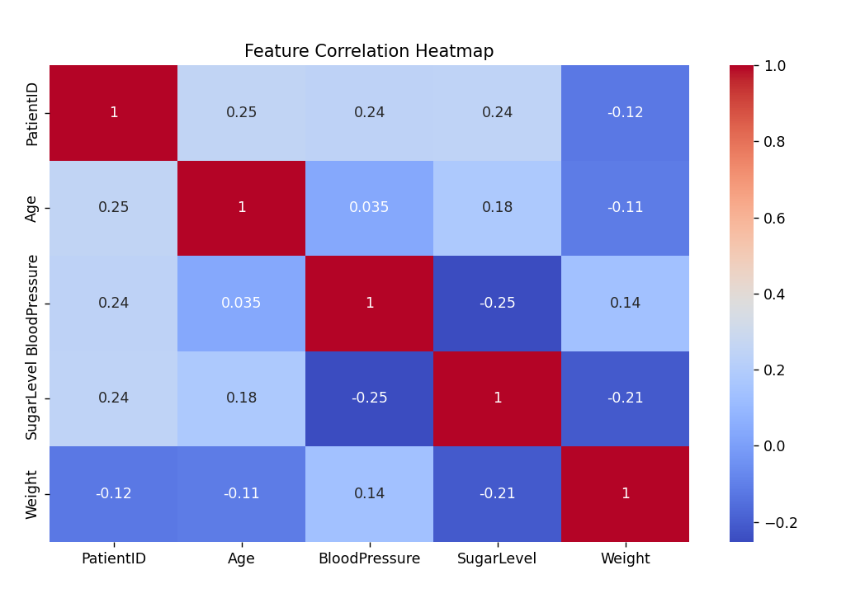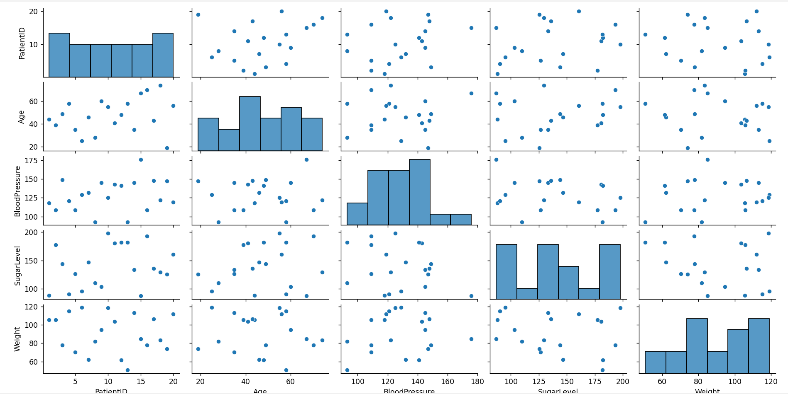

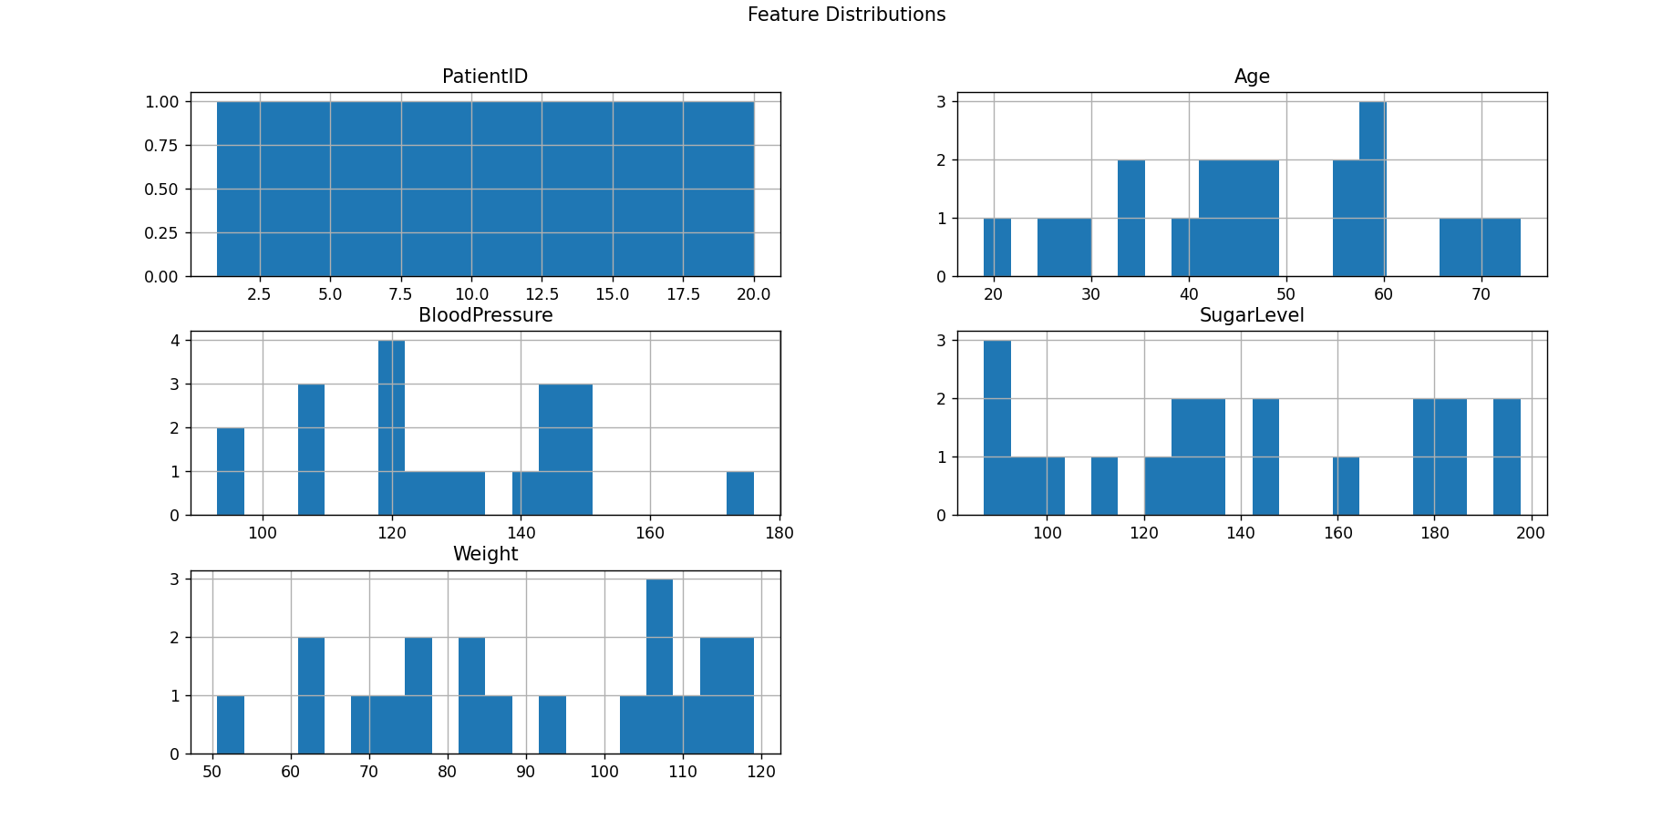

* **Pairplot:** Shows relationships between different numerical variables.
* **Heatmap:** Displays correlations between features.
* **Histograms:** Represent feature distributions.
* **Boxplot:** Helps detect outliers in the dataset.

**5. Conclusion**

This report demonstrates how machine learning techniques can be applied to healthcare data for predictive analysis. The Random Forest model achieved a good accuracy, highlighting its effectiveness in classifying patient health outcomes. Future improvements can involve more advanced deep learning models for even better predictions.